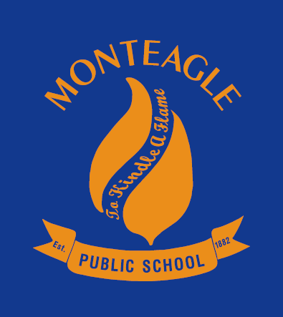

**Monteagle Public School**

**... small schools are GREAT schools ...**

**Unsure where to send your child to school in 2017? Please come and see our lovely school and some of the wonderful things we do. Enjoy some morning tea whilst having all of your queries answered. If you can’t make it on either of these days, please phone for an appointment.**

**Principal: Monica Gordon Ph: 63836207 Email: Monteagle-p.school@det.nsw.edu.au**

**Open Days**

**Wednesday 15th June - 11.30 to 1pm**

**Thursday 23rd June - 9.30 am to 11.30am**